Supporting Cycling for a healthier,
more connected Hobart
Candidate statement to Bicycle Network Tasmania
CR RYAN POSSELT | CANDIDATE FOR LORD MAYOR AND COUNCILLOR | CITY OF HOBART

Cycling is not a niche interest. It is transport, public health, family freedom, urban planning, recreation and an increasingly important part of Hobart's visitor economy.

I am a regular cargo-bike commuter, road and mountain-bike rider. I am also the Chair of Cycling South and a paramedic. In my spare time I am the administrator and creator of the Facebook group Hobart Cargo Bike Owners, bringing together local families and riders who are using initially niche but increasingly common cargo bikes for practical, everyday transport around Hobart.
My commitment is lived as well as political. Both of my children have bike-commuted from the age of 1, travelling from our West Hobart home to daycare in the city and Battery Point - initially as cargo-bike passengers and, as their skills developed, on their own bikes, as early as 2 on balance bikes. I want every Hobart family to have that choice without needing unusual confidence or bravery.

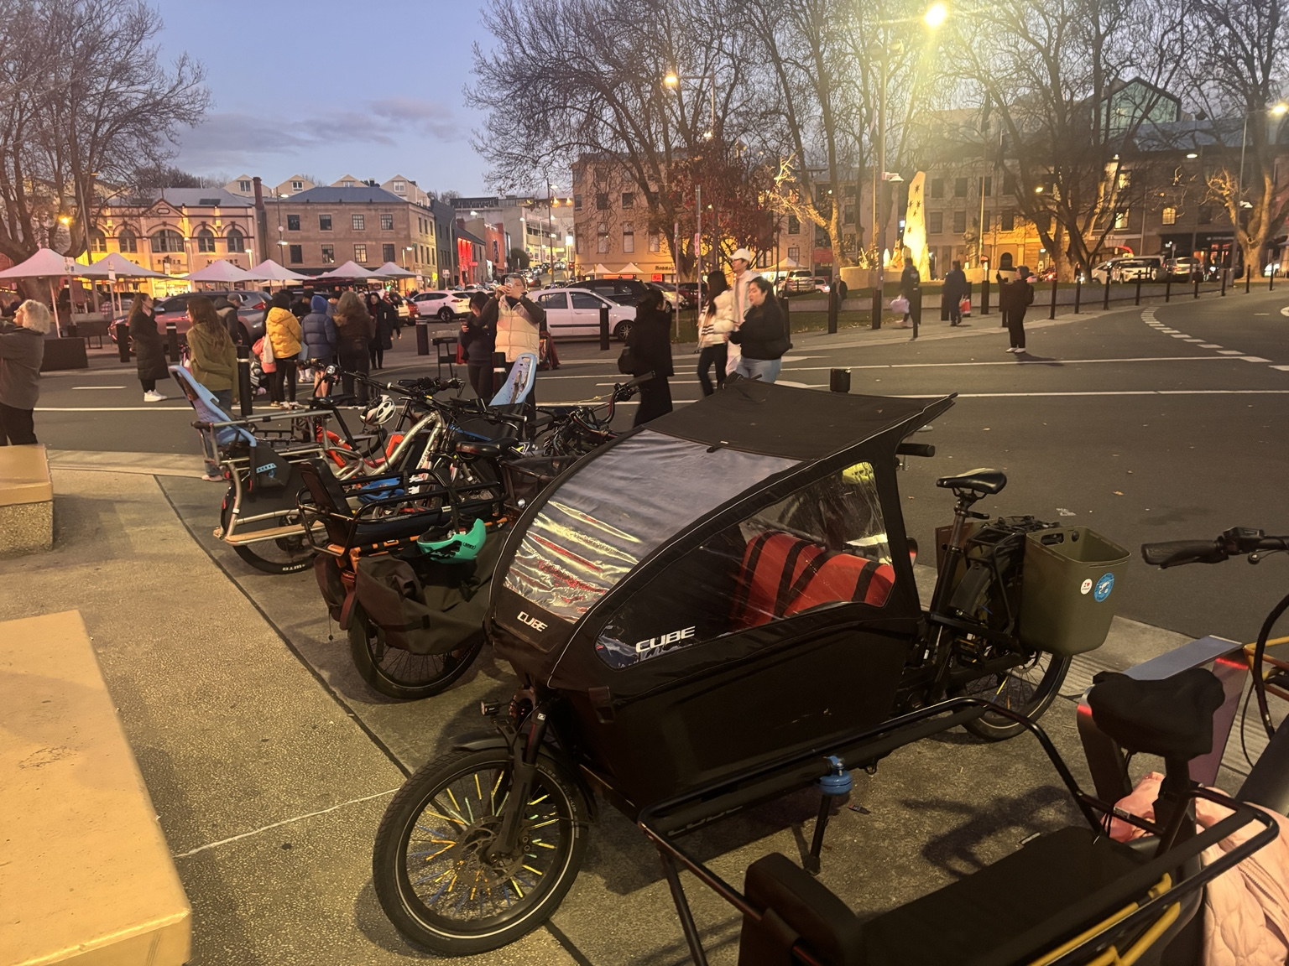
Dark Mofo:Cargo bike line-up, 2026. My Cube is in the foreground.

1 | Do you support Council's bike plan?
Yes - unequivocally.
I voted to endorse the Hobart Bike Plan 2026. Its commitment to a safe, connected and comfortable network for people of all ages and abilities - and its target of 10,000 daily bike trips by 2033 - gives Hobart a clear direction.
Adopting a plan is only the beginning. I want the next Council to establish a funded four-year delivery program, actively pursue State and Australian Government support and publish an annual progress report so the community can see which connections have actually been delivered.
MY RECORD I supported the Hobart Transport Strategy, the Collins Street transformation trial, continued funding when the State Government withdrew its contribution, the separated cycling connection in the final Collins Street block, the North Hobart Neighbourhood Plan, Augusta Road vision plan and crucially, the Hobart Bike Plan.
For me, "all ages and abilities" is literal. Safe routes give children independence, give parents a realistic alternative to the school or daycare car trip, and allow older and less-confident riders to participate. A network is successful when ordinary people can use it for ordinary journeys.
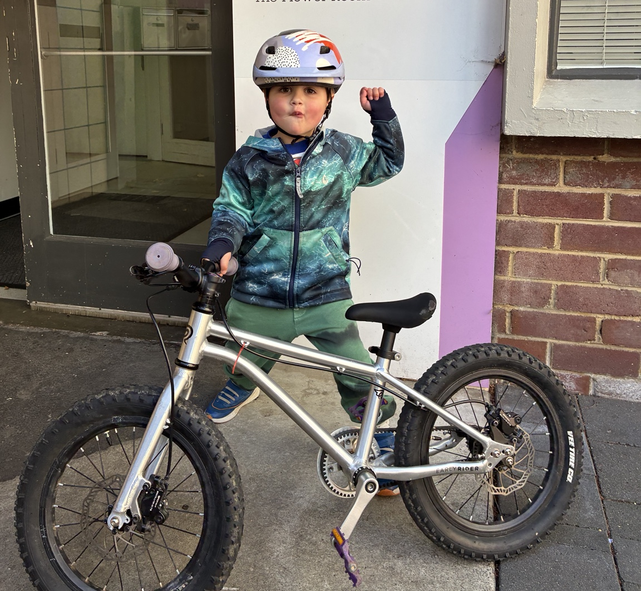
Hobart CBD: Three-year-old Reuben completing his first pedal-bike commute

2 | Which projects will you prioritise?
My first priority is continuity. A bike lane that ends abruptly before a difficult intersection does not provide the safe journey people need.

A PERMANENT COLLINS STREET CONNECTION
I support delivering a high-quality permanent connection from the Hobart Rivulet through Collins Street to Campbell Street. I strongly support the project's purpose, but I have also been candid about shortcomings in the tactical trial. The permanent design must learn from the evidence and address divider treatments, intersection and signal conflicts, bus-stop interactions and other operational issues, while retaining greening, dining, disability access and essential loading.

AUGUSTA ROAD AND NORTH HOBART
I will prioritise progressing the Augusta Road corridor toward construction as a safe, all-ages-and-abilities connection between Lenah Valley, North Hobart and the city, with evidence-led design and genuine engagement.

CLOSE THE MISSING LINKS
I support the Burnett Street connection, Campbell Street protection upgrades, safer crossings of Macquarie, Davey and Evan’s streets, and active-transport access to the proposed Sandy Bay ferry terminal, including improving line markings and looking for separation opportunities along Sandy Bay Road. These comparatively short projects can unlock much longer safe journeys.
I support the Battery Point Walkway as a critical link in our bicycle network. A link that some transport planners have described as the single best investment in Hobart’s network to reduce traffic and congestion.

NEIGHBOURHOODS, SCHOOLS AND EVERYDAY CYCLING
I will support neighbourhood greenways, safer routes to schools, lower-speed local streets, secure parking that accommodates cargo and adapted bikes, end-of-trip facilities, Ride2School initiatives and reliable maintenance of the network we already have.

ONGOING OPERATION OF THE E-BIKE LIBRARY
As an elected member that worked hard with Bicycle Network and Staff to develop and deliver the City’s e-bike Library, I am very supportive of ensuring it continues to operate effectively with the required financial support from council.
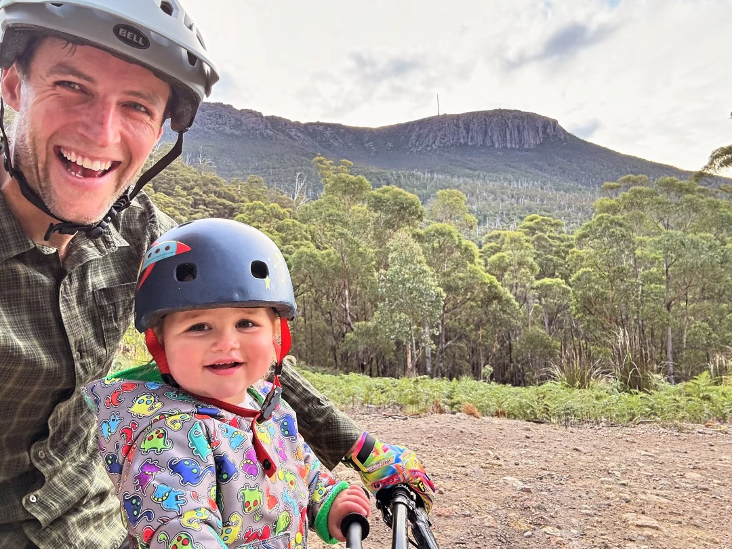
Bracken Lane: Cr Ryan Posselt and 18-month-old son on the trails of kunanyi / Mt Wellington.

Completing Riding the Mountain
As a keen mountain biker, I support continued Council funding and a clear, staged works program to complete the Riding the Mountain plan - the City's strategic blueprint for the lower foothills of kunanyi / Mt Wellington. It identifies the potential for 37 kilometres of new tracks to close gaps, broaden the range of riding experiences and create connected circuits and loops for riders of different abilities.
Mountain biking supports physical and mental health, gives families another way to be active and strengthens Hobart's visitor economy. Delivery should protect natural and cultural values, use sustainable trail design and separate uses where needed to reduce conflict between riders, walkers and runners. I will advocate for consistent annual funding, external co-funding and transparent reporting until the endorsed network is completed. (Appendix 1)
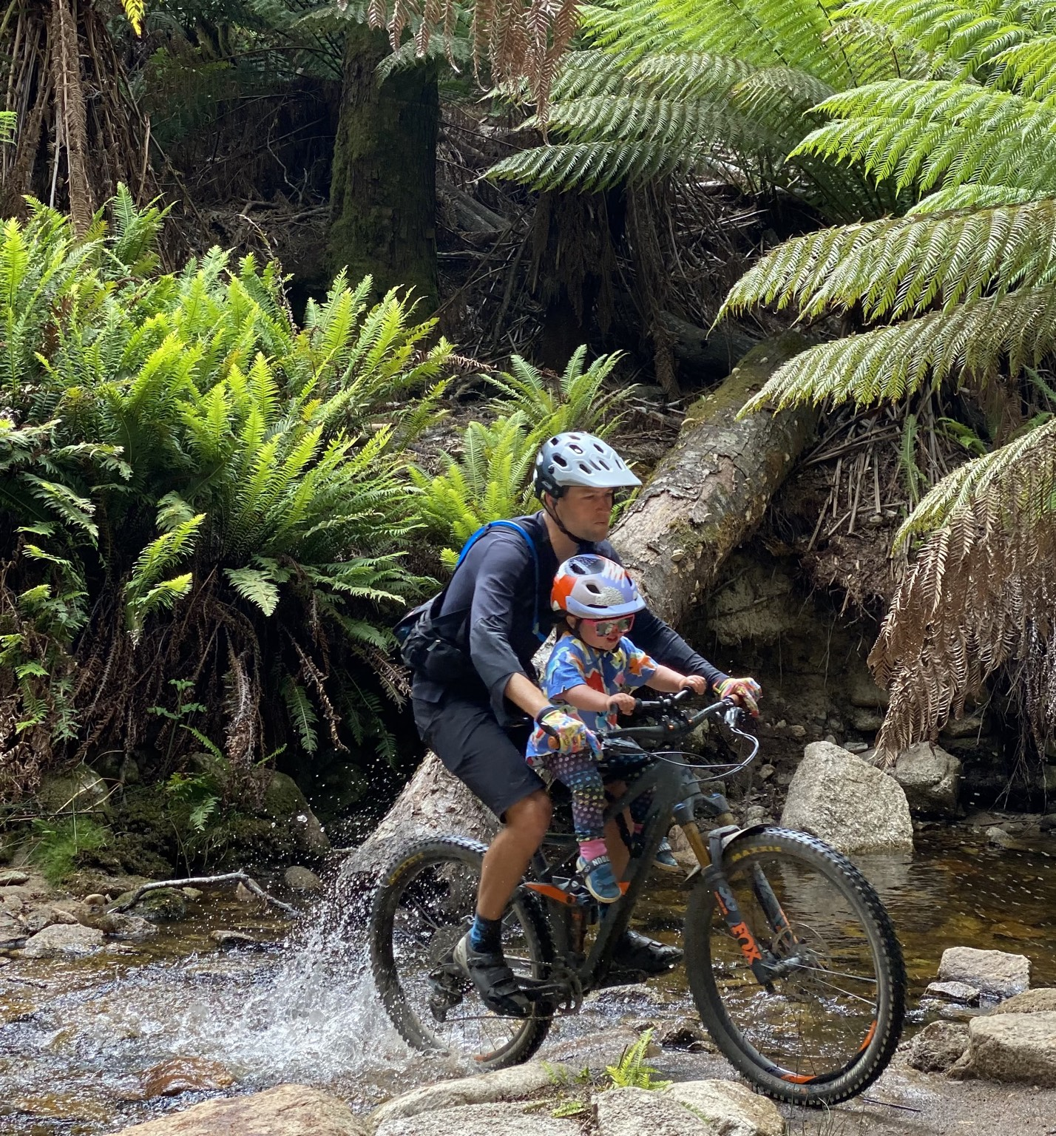
Blue Tier, Weldborough: Cr Ryan Posselt with 2-year-old son.

3 | Would you support bike lanes if parking moved or reduced?
Yes - where it is necessary for safety and continuity.
I have already demonstrated that through my Council voting record. Street space is a public asset and should be allocated according to safety, accessibility and overall community benefit. Decisions should be evidence-based, retain accessible parking and loading where required, consider nearby off-street alternatives and involve affected residents and businesses.
On-street parking cannot be allowed to veto every active-transport project. Where the genuine choice is between retaining a small number of general parking spaces and closing a dangerous gap in the cycling network, safety and connectivity should prevail.

Hobart will not become a safer cycling city through plans and slogans alone. It requires consistent votes, properly funded projects and a willingness to improve designs when the evidence tells us something is not working.

APPENDIX 1
KUNANYI / MT WELLINGTON | RIDING THE MOUNTAIN TRAILS COMPLETED THIS TERM
Completed and upgraded tracks | 13.9 km
Track name | Length  (km) | Use type / IMBA  classification | Opened
Pipeline Track Extension – Gentle Annie bypass | 2.06 | Shared use  Green – easy | October 2025
Knocksofty | 3.5 | Shared use  Green – easy | April 2025
Swingset | 0.75 | Single use, MTB only  Blue | April 2025
Free Wheel’n | 2.3 | Single use, MTB only  Green – easy | March 2023
Rocky Wheel’n | 2.83 | Shared use, uphill MTB only  Green | March 2023
Upper Luge – (formalised – upgrade) | 0.65 | Single use, MTB downhill only  Blue | April 2022
Crosscut | 1.5 | Shared use, uphill MTB only  Green | April 2022
Slackline | 0.3 | Shared use, dual direction  Green | October 2024
Description: In this term of council alone the city has completed a total of eight new trails have been constructed and opened, including a mix of shared-use tracks and dedicated mountain bike trails catering to a range of user abilities. These projects represent approximately 13.9 km of new trail added to the network over the term. The City has invested approximately $1.75 million in the construction and development of new trails during this period, supported in part by State and Federal grant funding.

